Miquon School Raffle May 15, 2016:

A. Bohemian Electric Guitar-
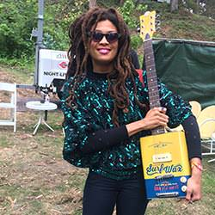
Upcycled Electric “Boho” Guitar made from an oil can with a crisp, mellow sound. Amp not included. Donated by Miquon Parents Eric Mayers and Laura Lamey. Value $300

B. The Holy Day Lounge by Jean-Marie Massaud, is a timeless polished chrome and brown leather architectural chair. 30" D X 27" W X 26.5" H; SH: 14.25" Donated by Coalesse. Value $3,986.00
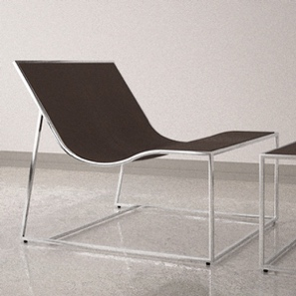

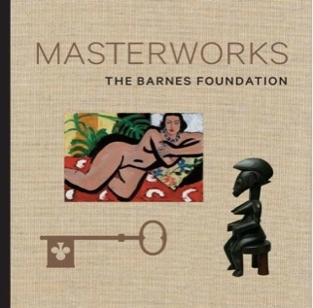
C. Philly Masterpieces.
Two anytime passes to the Barnes Collection AND two passes to the Philadelphia Museum of Art. PLUS a copy of the 374-page, hardcover Masterworks book with over 150 beautifully reproduced images of some the most beloved works in the Barnes Collection. Donated by the Kaiserman Company.
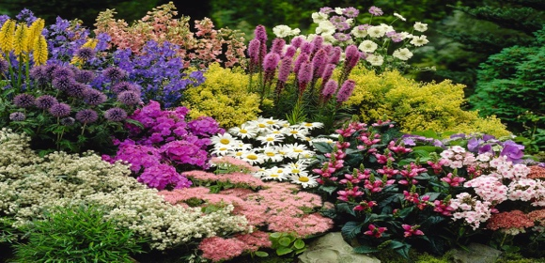
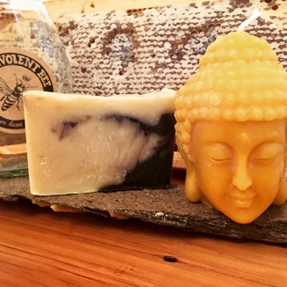
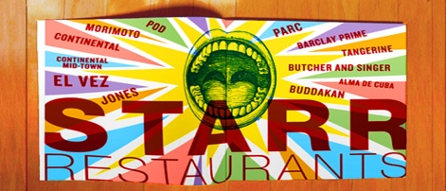

D. $100 Steven Starr Restaurant Gift Cards. (Two winners!!) Eat at any of Starr’s 22 Award-winning Philadelphia Restaurants! Donated by Kimball Office and Interface.
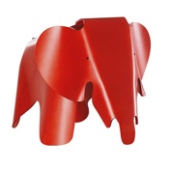
E. The Eames Elephant Chair in Miquon Red by acclaimed designer Charles Eames. A durable,
fun stool for children.
16.5" H x 16.25" W x 31" L. Donated by Vitra. Value $330
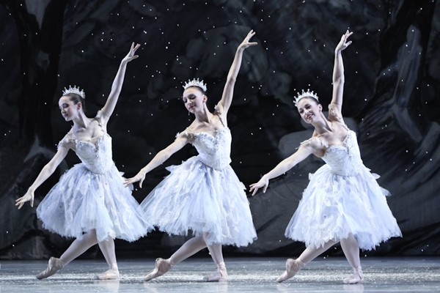

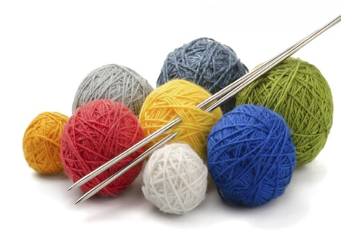

F. Two tickets to Pennsylvania Ballet’s production of George Balanchine's The Nutcracker in December 2016.
Donated by Pennsylvania Ballet.

G. Perennial Gardeners. One hour design consultation plus four hours gardening installation by Perennial Gardeners. Donated by Miquon Grandparent, Nancy Holm.
H. Benevolent Bee Gift Basket - 1lb jar of freshly extracted raw local honey, handcrafted soap, and a 100% beeswax Buddha candle. Donated by Miquon parents Steph Elson and Emile Bruneau.
I. Belgian Café - $50 Gift Certificate, 6-pack of assorted craft brews and 2 beer logo glasses.
Donated by the Belgian Café and Evan Seplow.
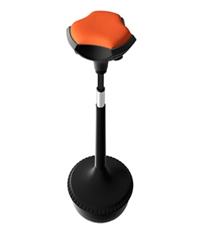
J. Pogo Chair by Compel – ergonomic design & 360º encourages active sitting. Adjustable 24”-34”. Donated by Kershner Office Furniture. Value $200

K. Knitting Lesson – Adults or Children can learn the basics to of knitting with Miquon Mom, Carol Ann Davidson.
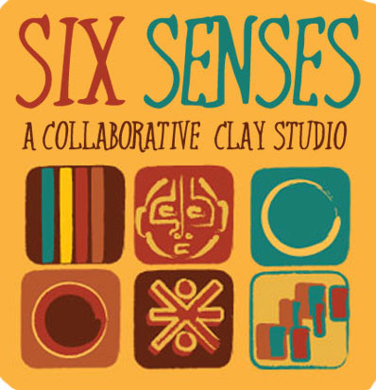
L. From Six Senses Clay Studio - A gift certificate worth $250, good for one week at studio art camp or one children's 10-class card. Donated by Miquon Mom Cornelia Kietzman.
M. Photo Shoot with Miquon’s own Mike Batchelor. Mike's skilled eye and sense of humor will be put to use in a 90 min. outdoor photo shoot at a mutually agreed upon location. Transportation not included. Expires 12/2016.

N. Eight Nia Classes at Allen’s Lane Art Center. Mondays 8:45am Sept.-Dec. Nia is a holistic dance practice. Certificate could alternatively be used for one private class for up to ten people. Donated by Lisa Zahren.
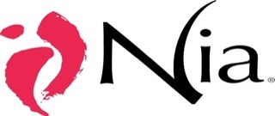

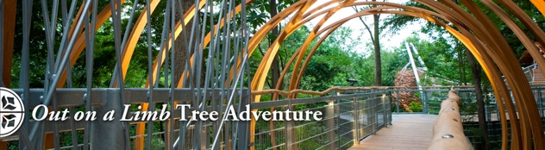
O. Morris Arboretum Membership. Enjoy this natural treasure, the garden railway, and discounts on classes and concerts for one year with your family. Donated by James and Arabella Pope.
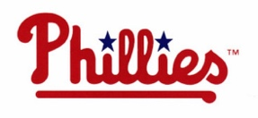
P. Four Premium Phillies Tickets near home plate- June 19, 2016 1:35 pm vs. Arizona Diamondbacks, includes parking. Donated by PFM Group.
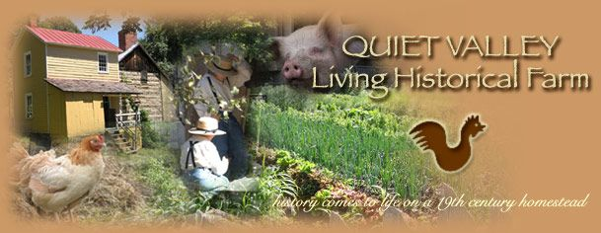
Q. Quiet Valley Living Historical Farm in Stroudsburg, PA. Gift basket and four admission passes to this 19th Century demonstration educational farm. Donated by Quiet Valley.
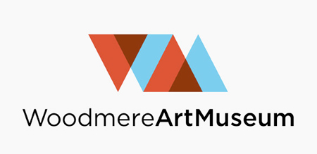
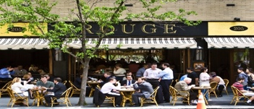
R. $150 at Rouge Restaurant- Rittenhouse Square’s best high-end cheese burger and so much more! Parking included. Donated by Rouge Restaurant.

S. $100 at Sampan Restaurant-
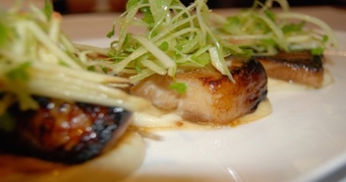
Modern Asian Street Food in the heart of 13th Street. Donated by Sampan Restaurant.

T. Watsu Massage - Julie Angel offers a one hour watsu session – in warm water based on the principles of meridian stretching from Zen Shiatsu. Donated by Julie Angel (of Miquon After School Program) Watsuwoman Massage.
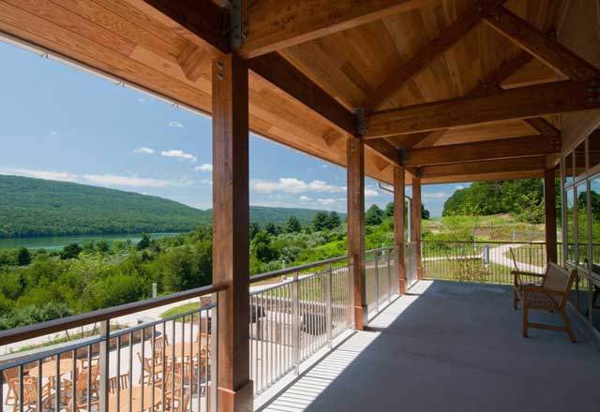
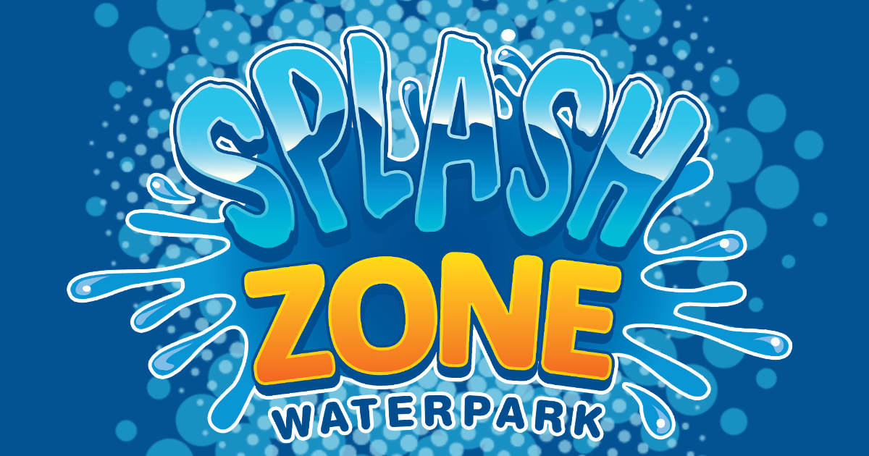
U. Four Day Passes to Splash Zone in Wildwood, NJ -- Donated by Splash Zone and Andy Weiner, Miquon Class of ’64.

V. One Week at The Miquon Day Camp! One week of day camp during the 2016 Season. Donated by The Miquon Camp.
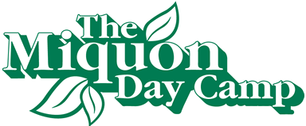

W. Woodmere Art Museum Membership –
One-year Family Membership includes access or discounts to family, film, and jazz programming. Donated by Woodmere Art Museum.

X. Franklin Institute Family Package- Four admissions tickets, passes to see Science of Pixar, theater passes, and parking. Plus, bonus items from the Pixar store! Donated by the Franklin Institute.

Y. Nature Inn at Bald Eagle Sate Park – $115 gift certificate. Donated by Nature Inn at Bald Eagle.
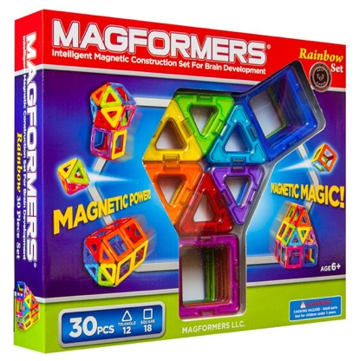
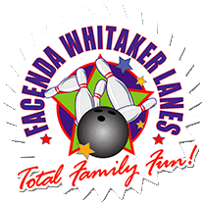
Z. Passes for Ten Free Bowling Games at Facenda-Whitaker Bowling Lanes in East Norriton! Family fun center with over 300 games! Some exclusions apply. Donated by Facenda-Whitaker Lanes.

AA. Steelcase Dash Light- High-performance LED task light. Donated by Steelcase. Value $500
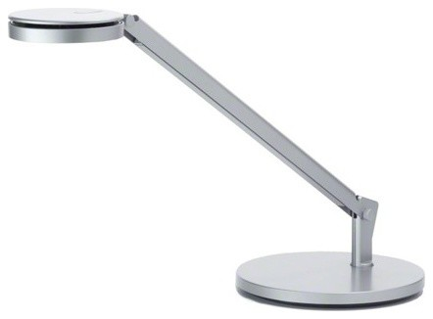

BB. Buoy Chair – a modern, active sitting chair. 18”x18. ”
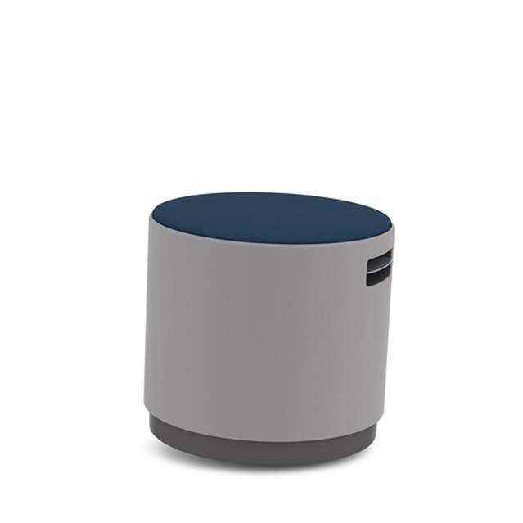
Donated by Corporate Interiors. Value $250

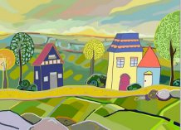
CC. 20x30 Canvas Art Reproduction-
Donated by Madison Art Consulting.
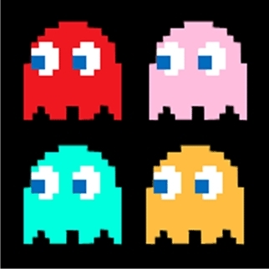

DD. 6”x 6” Ceramic Art Tile – Handcrafted and donated by Miquon Mom, Marea Palmer-Loh.
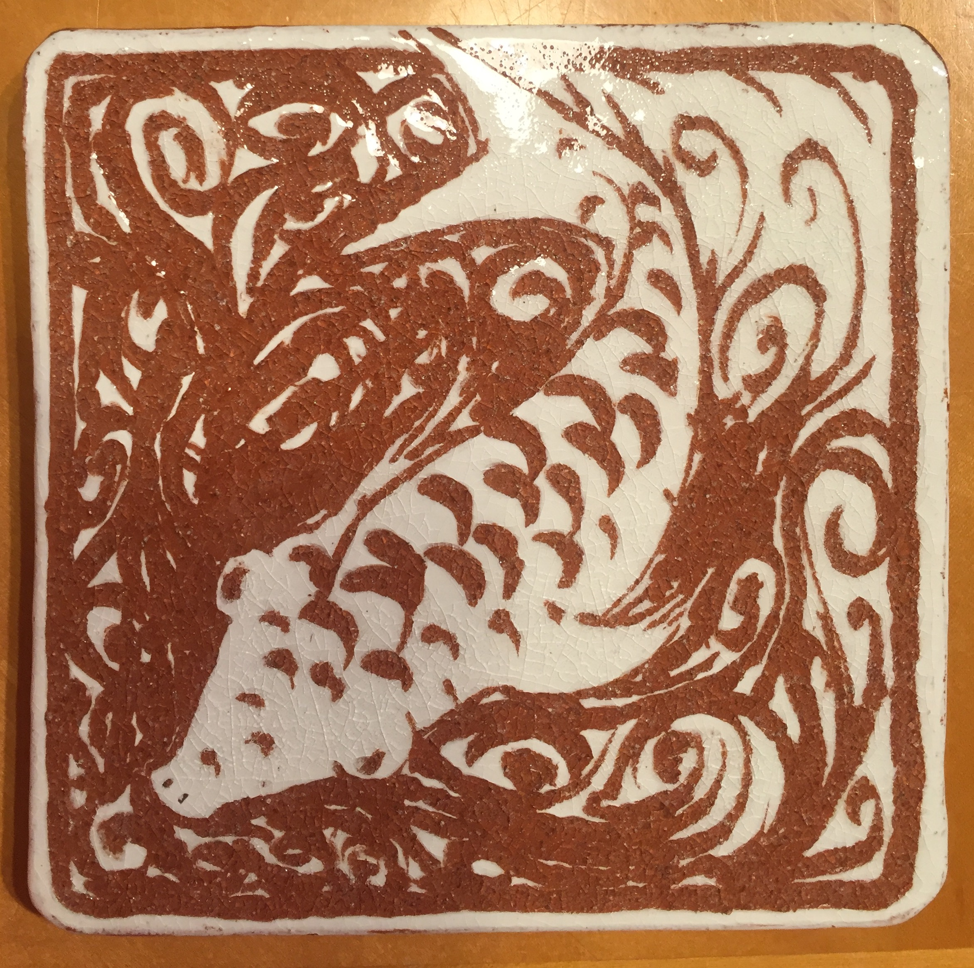

EE. Magformers 30 Piece Magnetic Game Set. Donated by Advanced Office Environments. Value $50
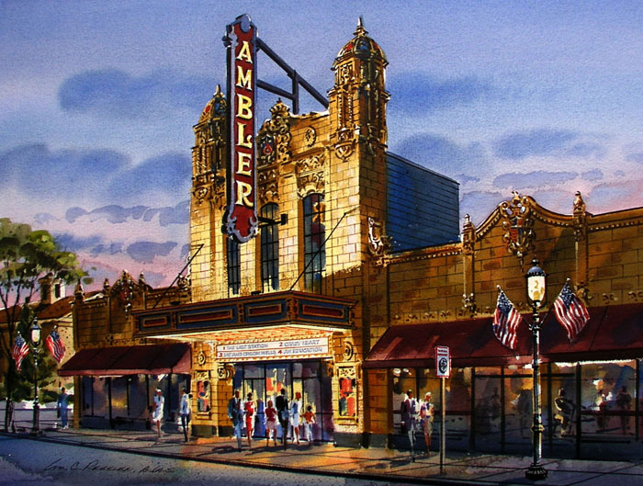
FF. Four Tickets to Ambler Movie Theater specializes in independent, art and foreign films. Tickets are valid Monday – Thursday only. Donated by the Ambler Theater.

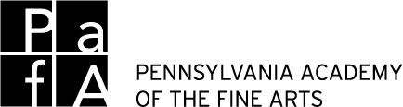

GG. One Year Family Membership to Pennsylvania Academy of Fine Arts. Access to collection, special exhibits, artist events all year! Donated by PAFA. Value $80

HH. Arcade Time for two hours for up to 6 Miquon kids at the home of Susannah Wolf and Douglas Gauck. Enjoy 18 restored vintage arcade games from Pac-man to Caterpillar. Priceless!

Please return paper tickets and cash or check to school or bring them to the Spring Fair on May 15, 2016!
OR
You can purchase tickets this year online at
www.miquonstore.org.

Questions: 610-828-1231 or deborahc@miquon.org

Many thanks to all of the families and businesses who made donations to support the raffle. A special thanks to Kim Raznov Coon of Raznov Designs who set up the new online raffle ticket sales platform.

