2025 Harts Lane, Conshohocken, Pennsylvania 19428-2414

tel: 610-828-1231 office@miquon.org
fax: 610-828-6149 www.miquon.org

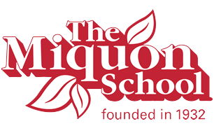

2016 - 2017 OPEN AND CLOSED DATES

September Monday 5 Labor Day – school closed
Tuesday 6 School opens for grades first through sixth
Wednesday 7 School opens for Nursery and Kindergarten

October Friday 14 Staff In-service Day - school closed
Monday 17 School closed

November Mon-Thur 7 - 10 Parent/Teacher Conferences
Friday 11 School closed
Wed-Fri 23, 24, 25 Thanksgiving break - school closed

December Friday 16 Winter Assembly (No Transportation needed for the day) Winter break begins, school closed through Mon, Jan. 2

January Tuesday 3 School reopens
Monday 16 Martin Luther King Day - school closed

February Friday 17 Staff In-service Day - school closed
Monday 20 Presidents’ Day - school closed
Tuesday 21 Doldrum’s Day - school closed

March Mon-Thur 20-23 Parent/Teacher Conferences and Book Fair
Friday 24 School closed, Spring break begins
School closed through April 3

April Tues 4 School reopens
Friday 28 Staff In-service Day - school closed

May Monday 29 Memorial Day - school closed

June Thursday 8 Last day for N & K, Skit Night
Friday 9 Graduation 9:30 am

